PUERTO RICO – STUDY GUIDE 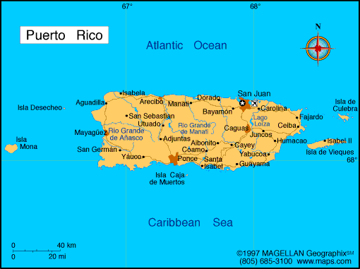 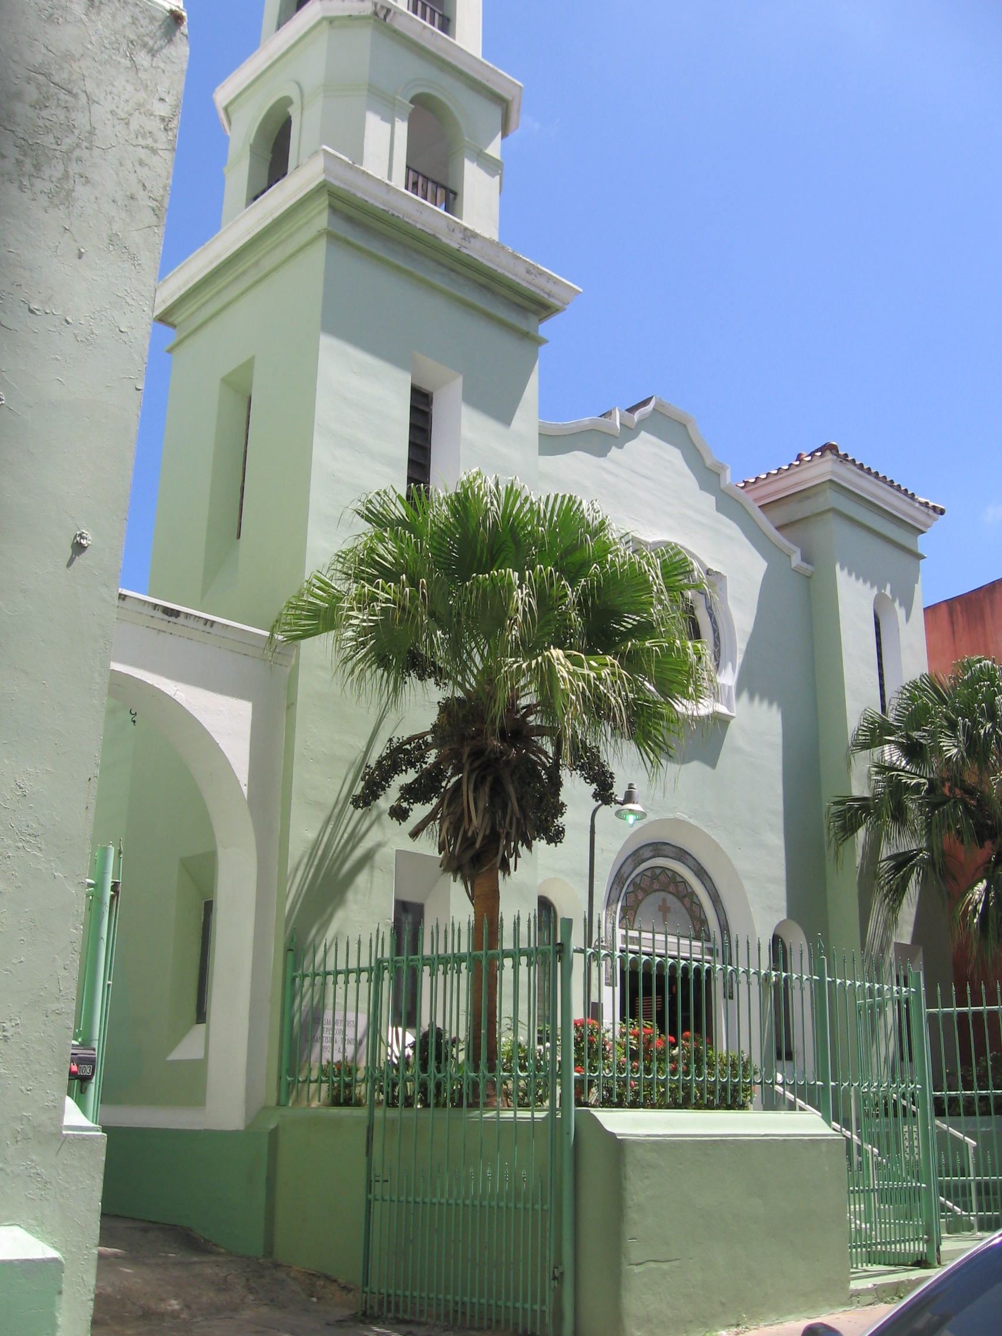

Capital: San Juan

Some things about San Juan: It’s located on the northern coast, the Atlantic. You can see a lot of architecture that is typical of the colonial Spanish era in Old San Juan. A famous Spanish fort is el Morro. New San Juan is very modern.

Caribbean National Forest: el Yunque (the only rainforest in North America)

Northern Coast: Atlantic Ocean

Southern Coast: Caribbean

Mountain Range: la Cordillera Central – runs through the middle of Puerto Rico.

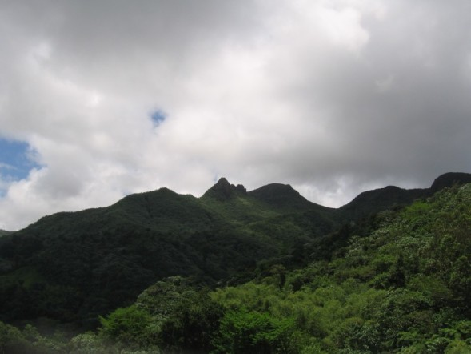

Typical Foods: Tostones, which are fried green plátanos or plantains. Also, arroz y habichuelas, which are beans and white rice. Also fried chicken, seafood, and they do have some KFCs and Burger Kings there as well!

A Special Amphibian: the Coquí, a tree frog

Ponce: It’s located on the southern coast, the Caribbean. It’s called “La Perla del Sur” – The Pearl of the South. There is a famous museum there called “Parque de Bombas” or Firehouse Park. It is an old firehouse, painted in red and black stripes, and has old fire trucks in it.

There are lots of beaches in Puerto Rico.

